

Ride Alliance Data Sharing Agreement

Table of Contents
Parties 1
Purpose 1
Period of Performance 1
General Terms and Conditions 1
Use of Information 1
Safeguarding Information 1
Re-disclosure of Information 2
Cause for Termination 2
Conflict of Interest 2
Exposure to DRCOG’s Business Information Not Otherwise Protected by Law and unrelated to this Agreement 3
Governance 3
Hold Harmless 3
Limitation of Authority 3
Severability 3
Survivorship 4
Termination 4
Waiver of Default 4
All Writings Contained Herein 4
APPENDIX A 5
APPENDIX B 6
APPENDIX C 8
APPENDIX D 9
APPENDIX E 16

Parties
This Agreement is made between the Denver Regional Council of Governments (DRCOG) and Ride Alliance (Information Recipient).

Purpose
This Agreement documents the conditions under which the DRCOG shares data with the Information Recipient. This Agreement documents the conditions under which the Information Recipient is approved to receive and use the data.

Period of Performance
This Agreement shall be effective for the duration of the Trip Exchange Hub including the initial pilot program.

General Terms and Conditions

Use of Information
The ownership of all information received by the Information Recipient under this Agreement remains with DRCOG and is not transferred to the Information Recipient.

The Information Recipient understands and agrees the parties shall construe this Agreement to provide the maximum protection allowed by law of the confidentiality of the information transferred pursuant to this Agreement.

Safeguarding Information
The Information Recipient agrees to the following:
- Comply with all state and federal laws and regulations surrounding the protection and confidentiality of the information
- Limit access and use of the information:
  - To the minimum amount of information
  - Only to Authorized Users
- Assure all Authorized Users with access to the data:
    - Understand their responsibilities regarding use of and access to the data pursuant to this Agreement,
    - Agree to abide by the terms of the “Use and Disclosure of Confidential Information Form” (Appendix A), and
    - Sign and date the “Use and Disclosure of Confidential Information Form” (Appendix A) before accessing the data.
  - All signed Appendix A forms must be maintained by the Information Recipient during the duration of the Agreement and for one year following the expiration of this Agreement. Information Recipient must provide DRCOG with any or all Appendix A forms immediately upon request by DRCOG.
  - A complete and up to date list of Authorized Users must be maintained by the Information Recipient at all times during the duration of this Agreement and must be provided to DRCOG immediately upon request.
- Notify DRCOG when Authorized Users or the contacts listed in this Agreement are no longer affiliated with the Information Recipient or are no longer authorized to access information provided under this Agreement.
- Comply with all Data Security requirements outlined in Appendix B.
- Unless otherwise agreed to in writing in this Agreement, or at the discretion and direction of DRCOG, the Information Recipient shall destroy all copies of any data provided under this agreement in accordance with the retention schedule noted in the funding agreement. Acceptable methods of destruction are described in Appendix B. Upon completion, the Information Recipient shall submit the attached Certification of Data Disposition (Appendix C) to DRCOG’s Contracts and Budget Manager within 30 calendar days of the end of this Agreement.
- In the event of a breach of the terms of this Agreement, or for any other reason, DRCOG may by written notice require the Information Recipient to immediately destroy all copies of any data provided under this Agreement. Acceptable methods of destruction are described in Appendix B. Upon completion, the Information Recipient shall submit the attached Certification of Data Disposition (Appendix C) to DRCOG’s Data Sharing Coordinator within 30 calendar days of the date the notice was sent to the Information Recipient.

The Information Recipient acknowledges and agrees the obligations in this section survive completion, cancellation, expiration, or termination of this Agreement.

Re-disclosure of Information
Information Recipient is prohibited from disclosing in any manner all or part of the information provided under this Agreement, unless DRCOG has agreed otherwise in writing.

If the Information Recipient must comply with state or federal public record disclosure or freedom of information laws, and receives a records request where all or part of the information subject to this Agreement is responsive to the request, the Information Recipient will notify DRCOG’s Director of Administration and Finance of the request ten (10) business days prior to disclosing to the requestor. The notice must:
- Be in writing, and
- Include a copy of the request or some other writing that shows the:
    - Date the Information Recipient received the request; and
    - Department records the Information Recipient believes are responsive to the request and the identity of the requestor, if known.

Cause for Termination
The Information Recipient acknowledges unauthorized use or disclosure of the data/information or any other violation of this Agreement may be guilty of a misdemeanor, will result in the immediate termination of this Agreement, and result in denial of data/information in the future.

Conflict of Interest
DRCOG may, by written notice to the Information Recipient, terminate the right of the Information Recipient to proceed under this Agreement if it is found, after due notice and examination by DRCOG that gratuities in the form of entertainment, gifts or otherwise were offered or given by the Information Recipient, or an agency or representative of the Information Recipient, to any officer or employee of DRCOG, with a view towards securing this Agreement or securing favorable treatment with respect to the awarding or amending or the making of any determination with respect to this Agreement.

In the event this Agreement is terminated as provided above, DRCOG shall be entitled to pursue the same remedies against the Information Recipient as it could pursue in the event of a breach of the Agreement by the Information Recipient. The rights and remedies of DRCOG provided for in this section are in addition to any other rights and remedies provided by law.

Exposure to DRCOG’s Business Information Not Otherwise Protected by Law and unrelated to this Agreement
During the course of this Agreement, the Information Recipient may inadvertently become aware of information unrelated to this Agreement. Information Recipient will disregard such information and not use it, recognizing DRCOG relies on public trust to conduct its work. This information may be handwritten, typed, electronic, or verbal, and come from a variety of sources.

Governance
This Agreement is entered into pursuant to and under the authority granted by the laws of the state of Colorado and any applicable federal laws. The provisions of this Agreement shall be construed to conform to those laws.

In the event of an inconsistency in the terms of this Agreement, or between its terms and any applicable statute or rule, the inconsistency shall be resolved by giving precedence in the following order:
- Colorado state statutes and rules
- Federal statutes and rules
- Any other provisions of the Agreement, including materials incorporated by reference

Hold Harmless
Each party to this Agreement shall be solely responsible for the acts and omissions of its own officers, employees, and agents in the performance of this Agreement. Neither party to this Agreement will be responsible for the acts and omissions of entities or individuals not party to this Agreement. DRCOG and the Information Recipient shall cooperate in the defense of tort lawsuits, when possible.

Limitation of Authority
Only an authorized signatory in the Administration and Finance Division for DRCOG shall have the express, implied, or apparent authority to alter, amend, modify, or waive any clause or condition of this Agreement on behalf of DRCOG. No alteration, modification, or waiver of any clause or condition of this Agreement is effective or binding unless made in writing and signed by an authorized signatory in the Administration and Finance Division for DRCOG.

Severability
If any term or condition of this Agreement is held invalid, such invalidity shall not affect the validity of the other terms or conditions of this Agreement, provided, however, the remaining terms and conditions can still fairly be given effect.

Survivorship
The terms and conditions contained in this Agreement, which by their sense and context, are intended to survive the completion, cancellation, termination, or expiration of the Agreement shall survive.

Termination
Either party may terminate this Agreement for any reason upon 30 days prior written notification to the other party. DRCOG may terminate this Agreement, effective immediately if it finds the Information Recipient has used or disclosed data in any manner that violates the terms of this Agreement or appendices. If this Agreement is so terminated, the parties shall be liable only for performance rendered or costs incurred in accordance with the terms of this Agreement prior to the effective date of termination. Termination of this Agreement does not extinguish the Information Recipient’s obligation to delete any data or information received by following and submitting an Appendix C.

Waiver of Default
This Agreement, or any term or condition, may be modified only by a written amendment signed by DRCOG and the Information Recipient. Either party may propose an amendment.

Failure or delay on the part of either party to exercise any right, power, privilege or remedy provided under this Agreement shall not constitute a waiver. No provision of this Agreement may be waived by either party except in writing signed by DRCOG or the Information Recipient.

All Writings Contained Herein
This Agreement and Appendices contains all the terms and conditions agreed upon by the parties. No other understandings, oral or otherwise, regarding the subject matter of this Agreement and Appendices shall be deemed to exist or to bind any of the parties hereto.

APPENDIX A
Use and Disclosure of Confidential Information
People with access to confidential information are responsible for understanding and following the laws, policies, procedures, and practices governing it. The Information Recipient must maintain this form. All persons provided with access to information provided pursuant to this Agreement must understand and agree to abide by the following:
Confidential Information
Confidential information is information federal and state law protects from public disclosure. Examples of confidential information are social security numbers, and healthcare information that is identifiable to a specific person.
Access and Use of Confidential Information
- Access to confidential information must be limited to people whose work specifically requires access to the information.
- Use of confidential information is limited to purposes specified in this Agreement.
Disclosure of Confidential Information
- An Information Recipient may disclose an individual’s confidential information received or created under this Agreement to that individual or that individual’s personal representative consistent with law.
- An Information Recipient may disclose an individual’s confidential information received or created under this Agreement only as permitted under the Re-Disclosure of Information section of the Agreement and when state or federal law allows or requires disclosure.
Consequences of Unauthorized Use or Disclosure
An Information Recipient’s unauthorized use or disclosure of confidential information is the basis for DRCOG immediately terminating the Agreement. The Information Recipient may also be subject to administrative, civil, and criminal penalties identified in law.

Signature: | __________________________ | Date: | __________________________
Print Name: | __________________________ | Title: | __________________________

APPENDIX B
Data Security Requirements

DRCOG’s Information Security Manager must approve any changes to this section prior to Agreement execution. The Information Security Manager will send approval/denial directly to the DRCOG Administration and Finance contact.

The Information Recipient agrees:
- Its security practices and safeguards comply with the HIPAA Security Rule.
- It has taken steps necessary to prevent unauthorized access, use, or modification of the information in any form.
The Information Recipient agrees to protect the information as described below:
Passwords
Passwords must always be encrypted. When stored outside of the authentication mechanism, passwords must be in a secure environment separate from the data and protected in the same manner as the data.
- Complex passwords are:
- At least 8 characters in length
- Contain at least three of the following character classes: uppercase letters, lowercase letters, numerals, special characters
- Do not contain the user’s name, user ID, or any form of their full name
- Changed at least every 120 days
Data Storage
The data must not be copied, moved, or transferred by the Information Recipient in any manner unless specifically authorized within the terms of the Agreement.
Data Access
Information Recipient will notify DRCOG immediately whenever:
  - An authorized person in possession of such credentials is terminated or otherwise leaves the employment of the Information Recipient
  - Whenever a person’s duties change such that the person no longer requires access to perform work for this Contract.

If so authorized, the data must be encrypted during transmissions using a key length of at least 128 bits. Industry standard mechanisms and algorithms, such as those validated by the National Institute of Standards and Technology (NIST) are required.

Authentication must occur using a unique user ID and complex password. When the data is classified as Confidential, authentication requires secure encryption protocols and multi-factor authentication (MFA) mechanisms, such as hardware or software tokens, smart cards, digital certificates, or biometrics.

Accounts must lock after 5 unsuccessful access attempts, and remain locked for at least 30 minutes, or require administrator reset.
Paper documents
Paper records containing data classified as Confidential must be protected by storing them in a secure area accessible only to authorized personnel. When not in use, such records are stored in a locked container, such as a file cabinet, locking drawer, or safe, to which only authorized persons have access.
Data Disposition
If data destruction is required by the Agreement, the data must be destroyed using one or more of the following methods. A completed Appendix C must be submitted to the DRCOG data sharing coordinator. Failure to submit an Appendix C may result in the Information Recipient’s inability to receive future data.

Data stored on: | Destroyed by:
Hard disks/SSDs | Using a “wipe” utility which will overwrite the data at least three (3) times using either random or single character data, or  Degaussing sufficiently to ensure the data cannot be reconstructed, or  Physically destroying the disk.
Paper documents with Confidential information | On-site shredding, pulping, or incineration, or  Recycling through a contracted firm provided the contract with the recycler is certified for the secure destruction of confidential information.
Optical discs (e.g. CDs or DVDs) | Incineration, shredding, or completely defacing the readable surface with a course abrasive.
Removable media (e.g., USB flash drives, portable hard disks, or similar disks) | Using a “wipe” utility which will overwrite the data at least three (3) times using either random or single character data.  Physically destroying the disk.  Degaussing magnetic media sufficiently to ensure the data cannot be reconstructed.
Notification of Breach or Potential Breach
The Information Recipient shall notify DRCOG’s Information Security Manager and DRCOG’s Administration and Finance contact within one (1) business day of any suspected or actual breach of security or confidentiality of information covered by the Agreement.

APPENDIX C
Certification of Data Disposition

Date of Disposition: _________________

Check all that apply:

All copies of any datasets related to the Agreement have been destroyed from all data storage systems currently under or previously under control of the Information Recipient identified in the Agreement to effectively prevent any future access to the previously stored information.

All materials and media currently under or previously under control of the Information Recipient identified in the Agreement containing any data related to the Agreement have been physically destroyed to prevent any future use of the materials and media.

All paper copies of the Information currently under or previously under control of the Information Recipient identified in the Agreement related to the agreement have been destroyed on-site by crosscut or similar shredding.

Other (provide details in an attachment to this document).

The Information Recipient hereby certifies, by signature below, the data disposition requirements as provided in the Agreement, have been fulfilled as indicated above. By signing below, the person indicates they have the authority to sign on behalf of the Information Recipient.

Signature: | __________________________ | Date: | __________________________
Print Name: | __________________________ | Title: | __________________________

APPENDIX D

I. High-level architecture
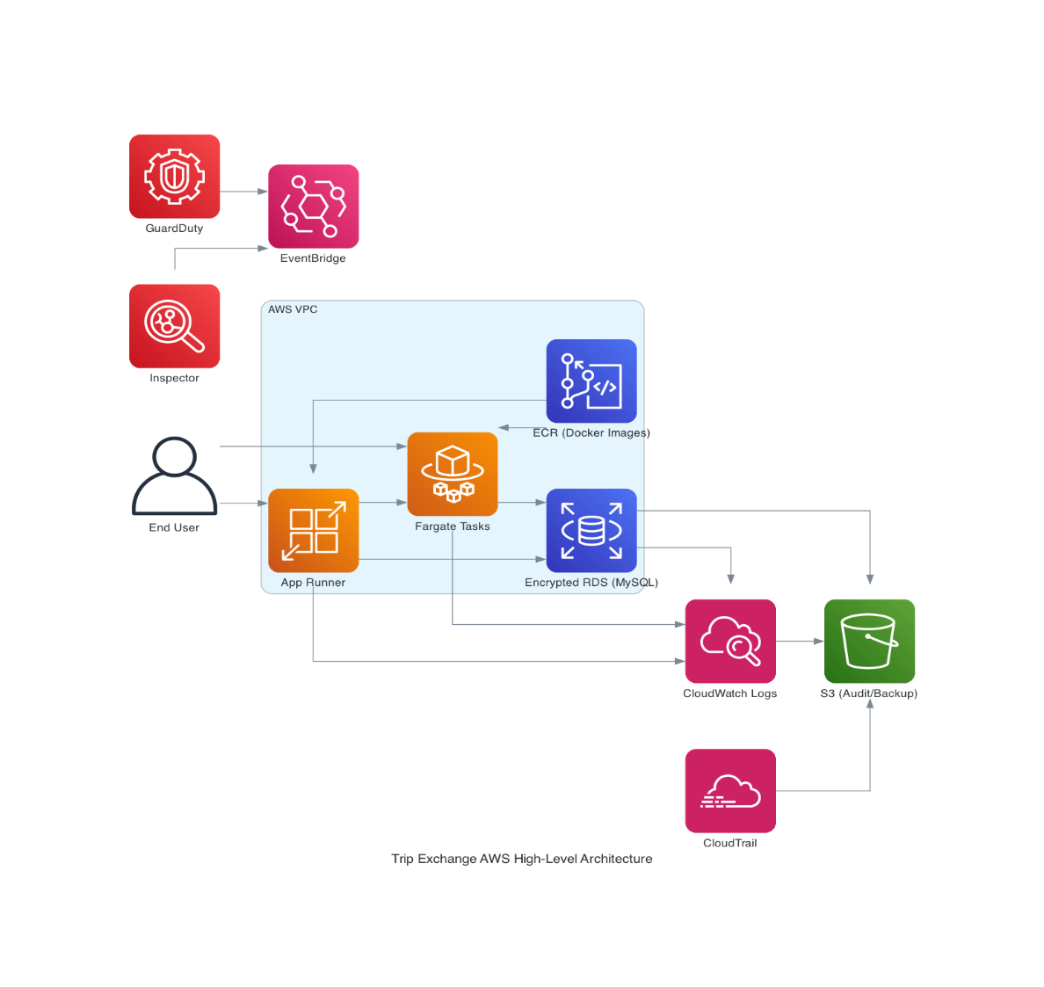
Amazon Web Services (AWS) was selected as the host because it meets HIPAA compliance. When data is stored in the Trip Exchange database, which is hosted on AWS, it is protected by AWS’ own technology from unauthorized access and can only be accessed via the functionality of the Trip Exchange software application or by an authorized database administrator associated with the Ride Alliance program. Each individual provider is responsible for HIPAA compliant data storage on their own internal servers or the hosting service they use.

The Trip Exchange application is deployed in a dedicated AWS VPC. It uses AWS App Runner and Fargate for compute, Amazon RDS (MySQL, encrypted) for persistent data, and Amazon ECR for container images. Security and compliance controls are implemented using AWS-native services, with all logs and evidence centralized within AWS CloudWatch.

AWS Key Management Service (KMS) is used for centralized encryption key management. KMS keys are used to encrypt data at rest and in transit, ensuring compliance with regulatory requirements such as HIPAA.

This environment is consistent with AWS guidance for deploying HIPAA-eligible workloads.

II. HIPAA Compliance
Amazon Web Services
- Physical security of datacenters, hypervisor/Nitro isolation, and many foundational controls. AWS undergoes independent third-party audits covering HIPAA for in-scope services and provides those reports via AWS Artifact.
- Native service controls and features (for example, RDS encryption at rest using KMS, VPC network isolation, CloudTrail, etc.) are implemented and operated by AWS.
Application Compliance
- AWS Config a fully managed service that continuously monitors, records, and evaluates the configuration of AWS resources against defined rules and compliance frameworks. In the Trip Exchange environment, AWS Config is enabled in all accounts and regions, with rules mapped directly to security best practices (encryption, logging, least-privilege access and network segmentation). Config records every change to supported AWS resources and maintains a detailed configuration history and resource inventory.
- AWS Security Hub is enabled in the Trip Exchange environment. It is used to aggregate findings from GuardDuty, Inspector and AWS Config.
Data Backups

Amazon RDS, S3, CloudWatch, CloudTrail, and IAM collaborate to provide a backup and restore workflow. RDS automates daily backups and supports manual snapshots, both of which are encrypted and stored in S3. CloudWatch monitors backup and restore operations, triggering alarms for failures or anomalies, while CloudTrail logs all backup, snapshot, and restore actions for auditability. IAM policies restrict who can initiate restores or access backup data. When a restore is needed, the process is initiated by an authorized user, logged by CloudTrail, and monitored by CloudWatch, ensuring both operational integrity and compliance. Regular restore tests validate the end-to-end process, and all evidence is retained for audit.

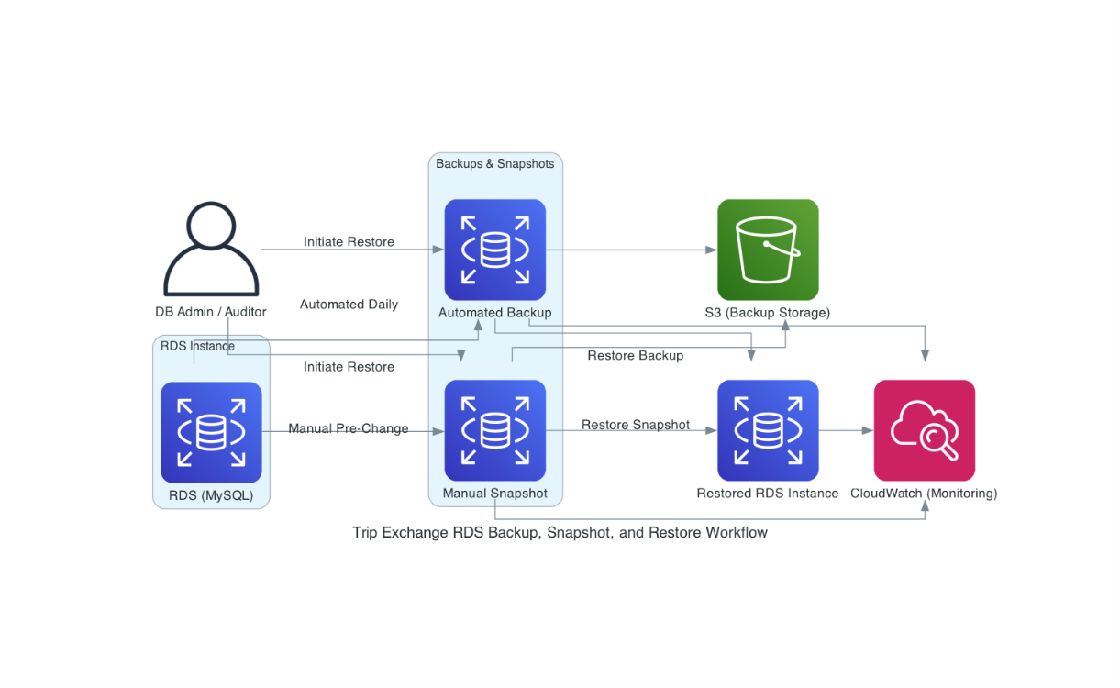

- Automated Backups: The Trip Exchange RDS instance is configured for automated daily backups with a 35-day retention period. These backups are encrypted using KMS customer-managed keys and are stored in S3. Automated backups are monitored for completion and failures via CloudWatch metrics and alarms.

- Manual Snapshots: Manual RDS snapshots are created before major schema or application changes, and also on-demand as needed. These snapshots are encrypted and stored in S3, with a minimum retention of 90 days. Manual snapshots are tagged for traceability and audit.
- Restore Workflow: Both automated backups and manual snapshots can be restored to a new RDS instance at any time. The restore process is initiated by a user with the appropriate IAM permission, and the restored instance is validated before being promoted to production or used for testing. All restore operations are logged in CloudTrail and monitored in CloudWatch.
- Backup Monitoring and Alerts: Backup and restore events (success, failure, missed schedule) are logged to CloudWatch and CloudTrail. CloudWatch alarms are configured to notify the operations team of any backup or restore failures, missed backup windows, or anomalies in backup duration. Backup monitoring dashboards are reviewed weekly.
- Restore Testing and Evidence: Quarterly restore tests are performed using both automated backups and manual snapshots. The process includes restoring to a test instance, validating data integrity, and documenting the results. Evidence of restore tests (CloudTrail logs, CloudWatch events, test results) is retained for audit.
III. Trip Exchange Malware Protections
In the Trip Exchange environment AWS GuardDuty, Inspector, Security Hub, and EventBridge form a layered threat detection and response system. GuardDuty continuously analyzes CloudTrail, VPC Flow Logs, and DNS logs for suspicious activity, while Inspector scans container images in ECR for vulnerabilities. Findings from both services are aggregated in Security Hub, which correlates and prioritizes them alongside compliance findings from Config and partner tools. EventBridge routes high-severity findings to alerting and ticketing systems for rapid response. Runtime logs from App Runner and Fargate are stored in S3 buckets for 365 days and IAM controls ensure that only authorized users can respond to incidents.

- Amazon GuardDuty is enabled in the Trip Exchange environment. Data is aggregated to a central security account and forwarded to Security Hub and EventBridge for automated alerting and ticketing. GuardDuty analyzes CloudTrail, VPC Flow Logs, and DNS logs for threats.
- Amazon Inspector is enabled in the Trip Exchange Amazon ECR environment. All container images are scanned on push, and findings are used to block promotion of vulnerable images. Inspector findings are also sent to Security Hub.
- Runtime Logging is configured for all container and application logs. They are centralized within AWS CloudWatch for analysis. GuardDuty and Inspector findings are correlated with CloudTrail and VPC Flow Logs for incident response.
- IAM Controls are configured to use least-privilege IAM policies are enforced for ECR and deployment pipelines. MFA is required for all privileged users.
- AWS manages host OS patching for Fargate/App Runner, eliminating a large class of host-level vulnerabilities. Images are regularly updated when patches are released.
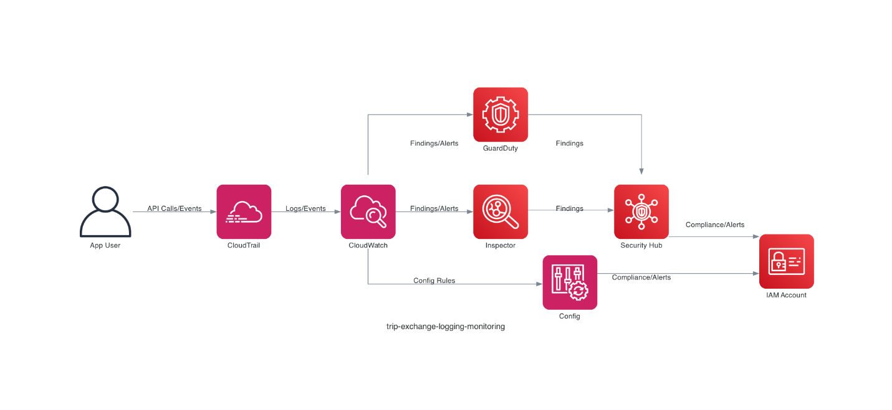
IV. Malware prevention

Image provenance and supply-chain hygiene
- Images are stored in a private Amazon ECR repository. The repository uses repository policies and IAM to control who can push images.
V. Network & perimeter protections

Isolated VPC + security groups + NACLs
Restrict network exposure: RDS access is whitelisted to specific IPs.

AWS WAF and Shield (application layer)
For web-facing endpoints (App Runner / ALB), the Trip Exchange uses AWS WAF to block common web exploits and Shield for DDoS protections, reducing attack surface that malware could exploit.

VI. Trip Exchange Data Interchange Flow

Glossary of Terms and Acronyms:
- TO = Transportation Operator.
- TO Application = a Transportation Operator’s service management system (e.g., Ecolane).
- TO API = the application programming interface (API) for a TO application.
- TE or TE Application = the Trip Exchange full application (Ride Alliance Trip Exchange Hub).
- TE API = the Trip Exchange application programming interface (API).
- Originator = the TO who submitted the trip record.
- Claiming = the TO who claimed the trip record.
- PHI = protected health information.

Trip Exchange Data Interchange Automated Process:
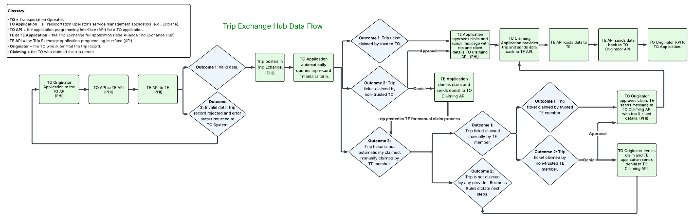

- TO Originator Application to the TO API: the TO Application selects a TO trip to send to the TE which initiates the trip ticket generation process that invokes the TO API* to transmit the trip data to an external entity.

- TO API to TE API: Trip ticket sent from the API of TO to the TE API.

- TE API to TE Application: Trip ticket is subsumed by the TE through its API.

- TE Application in control of data interchange process and runs data checks on trip information with 2 alternative outcomes:

  - Data is determined adequate and complete.

  - If data is inadequate or incomplete trip record, submission is rejected and error status is returned to TO Application (via TO API)—end of current trip ticket process.

- TO Application automatically queries trip record if meets criteria.

  - Trip ticket claimed by TO application of trusted TO.

    - TE application automatically approves claim of trusted TO and sends data message to TO Claiming API to confirm/validate the claim and provide TO with trip and client information.

  - Trip ticket claimed by TO application of non-trusted TO.

    - TE application denies claim (not typical situation) and sends data message to TO Claiming API of non-approval of claim.

  - Trip ticket is not automatically claimed by trusted TO and trip is posted in TE database as a valid trip ticket. Trip ticket claimed by manual process of TE member with 2 alternative outcomes:

    - Trip ticket claimed manually by TE member.

      - Trip ticket claimed by trusted TE member.

        - TO owner approves claim. TE application sends data message to TO Claiming API informing of claim approval and with trip and client ticket data.

      - Trip ticket claimed by non-trusted TE member.

        - TO owner denies claim. TE application sends data message to TO Claiming API informing of claim denial. Business rules dictate next steps.

    - Trip not claimed by any provider. Business rules dictate next steps.

- TO claimant of Trip Ticket delivers trip and sends trip completion data to TE API.

- TE API receives data and TE application invokes process that loads data into TE database.

- TE application invokes process that transmits completed trip data via TE API to API of TO Originator API.

- TO Originator API inserts/updates actual trip completion details into its TO Application.

Trip Exchange Data Interchange Manual Process:

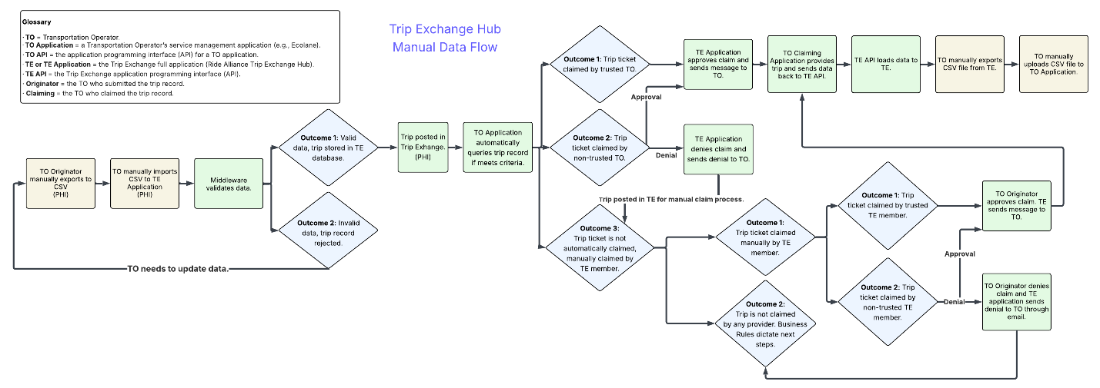
- TO Originator Application manually exports data to CSV file.

- TO manually imports CSV to TE Application.

- Middleware validates data with two potential outcomes:

  - Data is valid and trip is stored in TE database.

  - Invalid data, trip record is rejected.

    - TO needs to update data and process returns to first step.

- Trip posted in TE.

- TO Application automatically queries trip record if meets criteria.

  - Trip ticket claimed by TO application of trusted TO.

    - TE application automatically approves claim of trusted TO and sends data message to TO Claiming API to confirm/validate the claim and provide TO with trip and client information.

  - Trip ticket claimed by TO application of non-trusted TO.

    - TE application denies claim (not typical situation) and sends data message to TO Claiming API of non-approval of claim.

  - Trip ticket is not automatically claimed by trusted TO and trip is posted in TE database as a valid trip ticket. Trip ticket claimed by manual process of TE member with 2 alternative outcomes:

    - Trip ticket claimed manually by TE member.

      - Trip ticket claimed by trusted TE member.

        - TO owner approves claim and TE application sends approval message to TO.

      - Trip ticket claimed by non-trusted TE member.

        - TO owner denies claim and TE application sends denial message to TO.

    - Trip not claimed by any provider. Business rules dictate next steps.

- TO claimant of Trip Ticket delivers trip and sends trip completion data to TE API.

- TE API receives data and TE application invokes process that loads data into TE database.

- TO manually exports CSV file from TE.

- TO manually uploads CSV file to TO Application.

APPENDIX E

Account Types and Permissions
Access to client and trip data will be limited to the minimum number of individuals necessary for trip coordination.

Super Administrator:
- Create new Provider Administrator accounts.
- Setup service areas.
- Create Users for the Provider.
- Super Administrator accounts are limited to staff that lead the Ride Alliance project, including developers and project managers. Specifically, (2) DemandTrans Solutions developers, (1) TransitPlus Manager, and (1) DRCOG Ride Alliance Project Manager and (2) DRCOG Ride Alliance Project Coordinator.
Provider Administrators:
- Setup service areas.
- Create/Rescind claims as Claimant Provider.
- Approve/Decline claims as Originating Provider.
- Provider Administrator accounts are limited to one per agency. The agency will determine who at their organization should have this level of responsibility.
User Administrator:
- Approve/Decline claims on behalf of their Provider.
- User Administrator accounts are limited to staff actively participating in the client intake and trip coordination process.
Read-Only:
- View-only access to the Trip Exchange Hub.
- Read-Only accounts are limited to staff involved in the Ride Alliance project but who do not actively participate in the client intake or trip coordination process.
Training Requirements and Account Implementation

Training Requirements
Super Administrators are responsible for the development and maintenance of training materials. This includes online training sessions and other training materials.

All Provider Administrators and User Administrators are expected to attend one online training session and read and understand the training materials provided prior to accessing the Trip Exchange Hub.

Account Access
The DRCOG Super Administrator will be responsible for ensuring all users who wish to access the Trip Exchange Hub complete the required training prior to receiving login access. The DRCOG Super Administrator will maintain an accurate record of training dates and attendance. After training is completed, the DRCOG Super Administrator will provide participants with the “Ride Alliance New User Form”. Upon receiving the completed paperwork, the DRCOG Super Administrator will grant login access to participants. The record of trainings and completed “Ride Alliance New User Forms” will be saved in the DRCOG TPO Share Drive via the appropriate file path.

Username and Password Requirements
Username Requirements
- Usernames must be a valid email address. User is required to verify the email address.
Password Requirements
- Minimum 8-character length.
- Requires uppercase and lowercase characters.
- Requires special character.
Firebase Multi-Factor Authentication (MFA)
Firebase Authentication is used for identity (authentication) while continuing to use a Spring Boot backend for authorization and resource protection. This is required for all account types.

- Firebase Authentication manages user sign-in, account lifecycle, and MFA/federated identity, removing credential storage risk from our infrastructure.
- The Angular frontend enforces MFA, then calls a backend service to send an encrypted version of the Firebase user’s email to the Spring Boot endpoint
- The backend validates the identity, issues session/XSRF cookies, and continues to control authorization and business rules.
- This split keeps identity assurance with a specialist provider while allowing the backend to remain the system of record for authorization, auditing, and integration with existing Spring-based services.

Architecture
- Firebase sign-in & MFA
  - Users authenticate through Firebase Authentication (email/password, Google redirect, etc.).
  - The component forces multi-factor enrollment/verification before any backend call.
- Email encryption before backend call:
  - The email is encrypted client-side with AES-GCM (12-byte IV) and Base64 encoded.
- Backend validation
  - Sends { encodedEmailAddress } to POST /login/validateUser with withCredentials: true so cookies are exchanged.
  - The backend decrypts/validates the email and maps it to a Spring Security principal.
- Session establishment:
  - Success response must include an XSRF-TOKEN cookie. The client logs failure if the cookie is missing.
  - The response body may include a JWTToken plus user metadata (roles, provider information). These values are written to local storage and TokenService just as in the legacy login flow.
- Authorization & navigation: Spring Boot remains responsible for role/permission checks; the frontend persists role, provider, and user identifiers for routing and follow-up API calls.
End-to-end flow (current implementation)
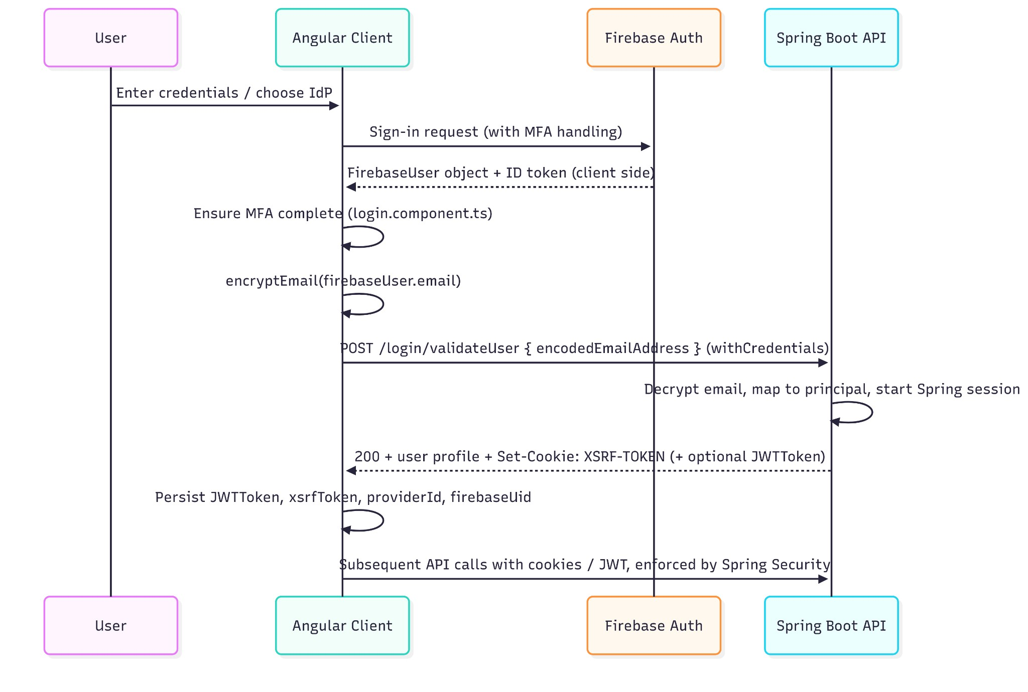
Session establishment detail
Firebase Authentication (security advantages)
- Delegated credential management – Password hashing, breach detection, MFA enforcement, social sign-in, and account recovery are handled by a provider with dedicated security teams.
- Reduced attack surface for Spring Boot – The backend never handles raw credentials; it only consumes validated identity assertions (currently encrypted email, recommended to evolve toward ID token validation).
- Built-in MFA and adaptive risk – Firebase offers SMS, TOTP, and app-based second factors plus integrations with enterprise IdPs, letting us enforce strong authentication without building custom flows.
- Continuous security maintenance – Firebase rotates signing keys, patches vulnerabilities, and provides audit logs, offloading upkeep from our engineering teams.
- Cross-platform consistency – The same identity provider can serve web, mobile, and future clients, simplifying least-privilege enforcement and de-provisioning.

Account Termination
All user accounts types (Super Administrator, Provider Administrator, User Administrator, and Read-Only) will be audited by the DRCOG Super Administrator on a semi-annual basis to verify if access is still necessary. As appropriate, the DRCOG Super Administrator will verify user account information with an organization’s designated Provider Administrator. If determined access is no longer needed, accounts will be terminated by the DRCOG Super Administrator. Accounts are terminated in the Trip Exchange Hub Administrator Dashboard by selecting the “Deactivate User” action button.

